Visualization of Support Vector Machine
using Sequential Minimal Optimization

Sachet Rajat Kumar Patil
Department of Computer Science
PES University
Bangalore, India
sachetrk.patil@gmail.com

Ananth Rastogi
Department of Computer Science
PES University
Bangalore, India
ananth.rastogi1729@gmail.com

Abstract— Visualizing the working of support vector machines (SVM) iteratively using the sequential minimal optimization (SMO) algorithm. The SVM generates a large and extremely complex quadratic programming (QP) problem, which had posed numerous mathematical challenges, until the proposal of the SMO. In this paper, a visual representation of the in-depth working of the SMO algorithm for SVMs is depicted. The kernel usage for the scope of this paper is restricted to the linear and gaussian kernels. Dummy data generator functions have been used to generate data used as train data to depict the decision boundaries calculated by the SMO for the SVM.
Keywords—SVM, SMO, kernel, QP

Introduction
Support Vector Machine (SVM) is one of the most feasible and well known techniques for solving classification problems. The support vector machine is a linear classifier built for a binary classification case. Invented by Vapnik in 1979, it quickly became one of the most used classifiers for real world classification problems. The only problem posed by the SVM was the extremely complex quadratic programming (QP) problem that it generated. This problem received an elegant and feasible solution in the form of the SMO, proposed by John Platt in the year 1998, from Microsoft Research. It became the fastest quadratic programming optimization algorithm, which solved the QP problem of the SVM effortlessly.
The Sequential Minimal Optimization algorithm works on the principle of decomposition of a large problem into subsets of very small problems. This technique exploits the fact that the optimization problem for two data points admits an analytical solution, thus ruling out the need for an iterative quadratic programming optimizer.
One of the key ways to understand the working of the SMO algorithm is to analyse the decision boundaries plotted by the SVM visually, in every iteration of the algorithm.
Every set of chosen and updated multiplier values from the SMO, results in a different decision boundary being plotted. Analysis of these iterative plots which depict the change in decision boundaries with the change in the multiplier values (from initial to final optimal multiplier values) leads to a great visual understanding of the working of the SMO algorithm.

Overview of SVM
The support vector machine is a linear classifier built for a binary classification case. An SVM constructs a hyperplane that separates a set of points labelled y = −1 from a set of points labelled y = +1, using a vector of features x. The hyperplane is represented by the following equation:
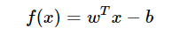
with vector w and scalar b to be determined. The class labels are determined as follows:
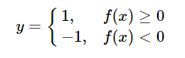
The classifier should correctly separate the positive labelled points and the negative labelled points with a bigger “gap” proportional to 1/||w||. As we are looking for a large margin between the classes, a new constraint is introduced, and the optimisation problem transforms into the following:
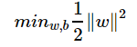
Subject to:
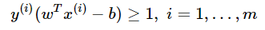
where m denotes the length of training samples.
The optimisation problem can then be converted to the dual form:
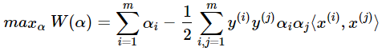
with the following constraints:
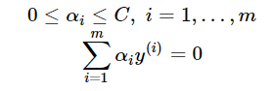
where:
represents the inner product of the two feature vectors, C is a regularisation parameter, α_{i} is the Lagrange multiplier associated with the i^{th} training sample, and b is a scalar bias term to be calculated.

Working of SMO

Iterative process
The Sequential Minimal Optimization algorithm breaks down a large problem into subsets of very small problems, which are relatively much easier to solve. The step wise working of the SMO algorithm is as follows:
- From the vector of multiplier values, two multiplier values are chosen, and their values are optimised while the remaining multiplier values are kept constant.
- After the optimisation of the two values, two more are chosen, and optimised over. (selection follows heuristics, which is based on error cache).
- The problem constraints define the length of the process, as it plays the role of deciding when the optimization reaches convergence.
The expected result of the SMO algorithm is non zero values in the multiplier vector, where the data point is closest to the decision boundary.

Kernel usage
Two kernels have been considered. The linear and gaussian (also known as radial basis function) kernels.
The linear kernel is defined as:
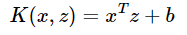
where x and z are input feature arrays, and b is a scalar bias term (initially set to 1).
This linear kernel is used to create a purely linear decision boundary.
The gaussian kernel is defined as:
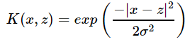
where x and z are input feature arrays, and σ is a parameter to decide the width of the kernel.
In the case of the kernel returning a value of 1, we understand that the training samples in x and z vectors have the same feature vector, and a value of 0 indicates non similar vectors.

Visualization
Visualization of the changing decision boundaries throughout the course of the SMO algorithm is the heart of this paper. It provides a strong base to understanding and analysing the working of the SMO algorithm with the modifications it makes to the multiplier values.

Linear kernel plots
Iterative plots have been shown, ranging from initial multiplier values, all the way till the final optimal values. In order to depict the linear kernel usage effectively, the make_blobs function from the python package sklearn has been used to create dummy data points. Some of the plots observed are depicted below:

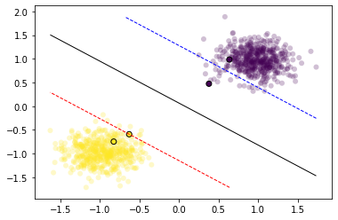
Initial plot with first pair of multiplier values: 0,0

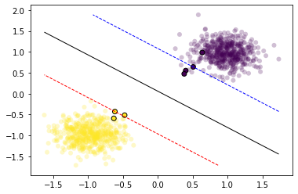
Plot of iteration 20, with multiplier values:0.249,0

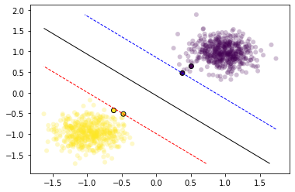
Plot of iteration 250, with multiplier values:1.33,1.33

Gaussian kernel plots
In order to depict the usage of gaussian kernel effectively, two sets of dummy data point generator functions have been used from the python package sklearn.
Below are the plots using the function make_circles:
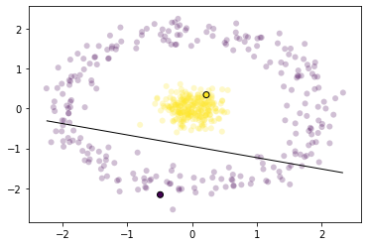
Initial plot with gaussian kernel using first set of multiplier values:0,0

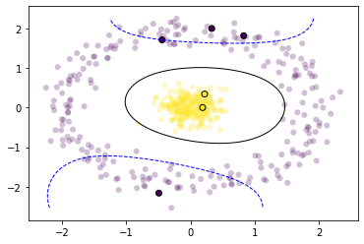

Iteration 20 with gaussian kernel with multiplier values:0.21,0.25

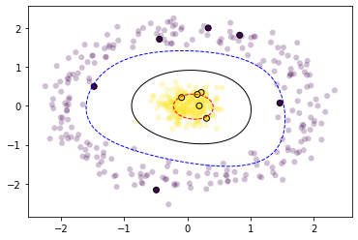

Iteration 45 using gaussian kernel with multiplier values:2.77,0.05

Iteration 80 using gaussian kernel with multiplier values:0.0,0.076

Below are the plots using the data generator function make_moons:

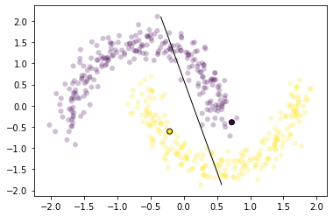
Initial plot with gaussian kernel using first set of multiplier values:0,0

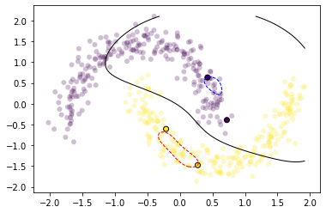
Iteration 25 using gaussian kernel using multiplier values:0.61,0

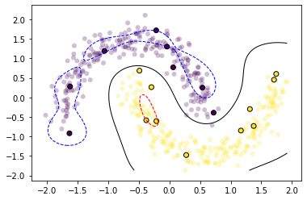
Iteration 55 using gaussian kernel with multiplier values:
0.82,0

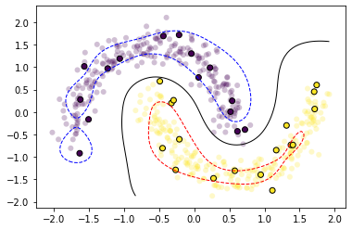
Iteration 75 using gaussian kernel with multiplier values:
0.23,0.94

Behaviour in presence of outliers

Setting high value of C (regularization constant):
A high value of C, ensures that the model is penalized highly for an incorrect classification. In the presence of less outliers, it is generally preferred to keep the value of C reasonably high.
The following plots depict the change in decision boundaries iteratively, and the model’s sensitivity towards outliers, provided a high value of C. ( Test case considered C = 1000)
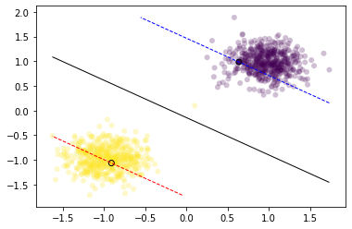
Initial outlier plot using linear kernel with first set of multiplier values:0,0

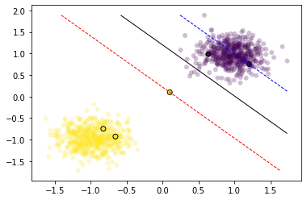
Iteration 15 outlier plot using linear kernel with multiplier values:1.06,1.06

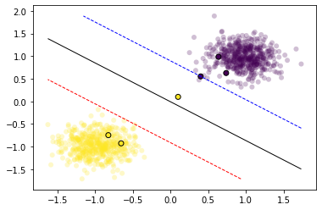
Iteration 30 outlier plot using linear kernel with multiplier values:3.65,3.65

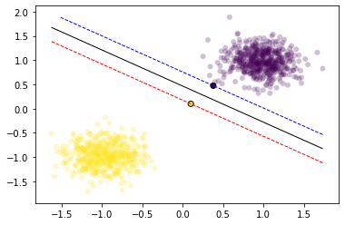
Iteration 65 outlier plot using linear kernel with multiplier values:7.34,7.34

      - Setting low value of C (regularization constant)
A low value of C ensures that the model is not harshly penalized for an incorrect classification. This is preferred when there are a significant number of outliers.
The following plots depict the change in decision boundaries iteratively, and the model’s sensitivity towards outliers, provided a low value of C. (Test case considered C = 1)

Initial soft outlier plot using linear kernel with multiplier values:0,0

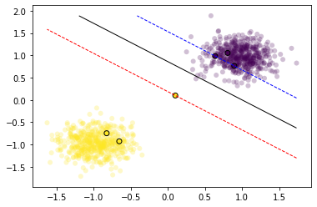
Iteration 20 soft outlier plot using linear kernel with multiplier values: 1.16,1.16

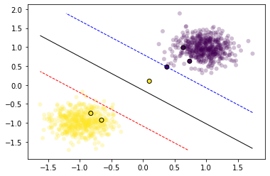
Iteration 45 soft outlier plot using linear kernel with multiplier v alues:0.52,0.0

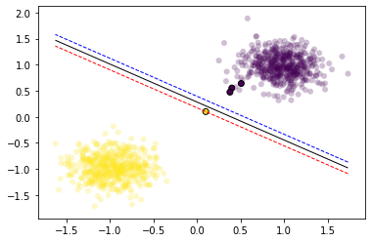
Iteration 70 soft outlier plot using linear kernel with multiplier values:5.98,5.98

Conclusions
The change in decision boundaries can be visualised with the change in the values of the multipliers updated by the SMO algorithm. We also observe the sensitivity of the model towards outliers with the change in values of ‘C’, and corresponding high values of the multipliers. Thus, visualizing the algorithm provides a good insight into its in-depth working.

References

- J. Platt, "Fast training of support vector machines using sequential minimal optimization:' in Advances in Kemrl Marhods -Support Vector Laming, B. Schdlkopi, C.1.C Burges. and A.J. Smala. editors, pages 185-208. MIT Press, Cambridge. MA, 1999.J. Clerk Maxwell, A Treatise on Electricity and Magnetism, 3rd ed., vol. 2. Oxford: Clarendon, 1892, pp.68–73.
- V.N. Vapnik, “The nature of statistical learning theory,” Springer, New York, 1995.
- Patrick H Winston, “Learning: Support Vector Machines,” Fall, MIT, 2010

